**LAPORAN PRAKTIKUM**

**BASIS DATA**



**NAMA**

IMAS AYU WARDANI

**NIM**

24060119120005

**PRAKTIKUM KE**

**3**

**ASISTEN PRAKTIKUM**

ANGGER MUHAMMAD ELEGANT

MOHAMAD ARYARAFI DANENDRA

**ERD MODUL 2 :**

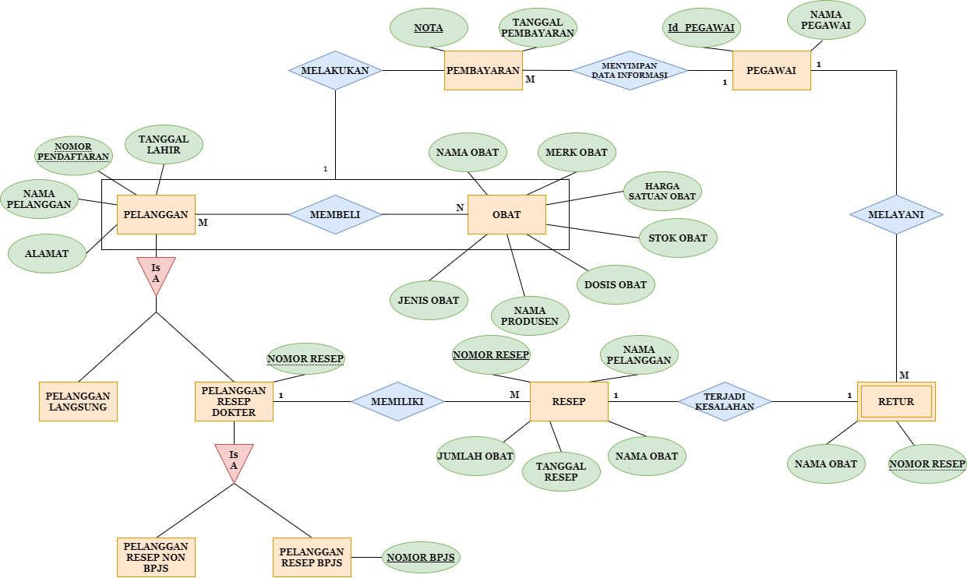

**TRANSFORMASI MODEL DATA KE MODEL FISIK**

1. PELANGGAN

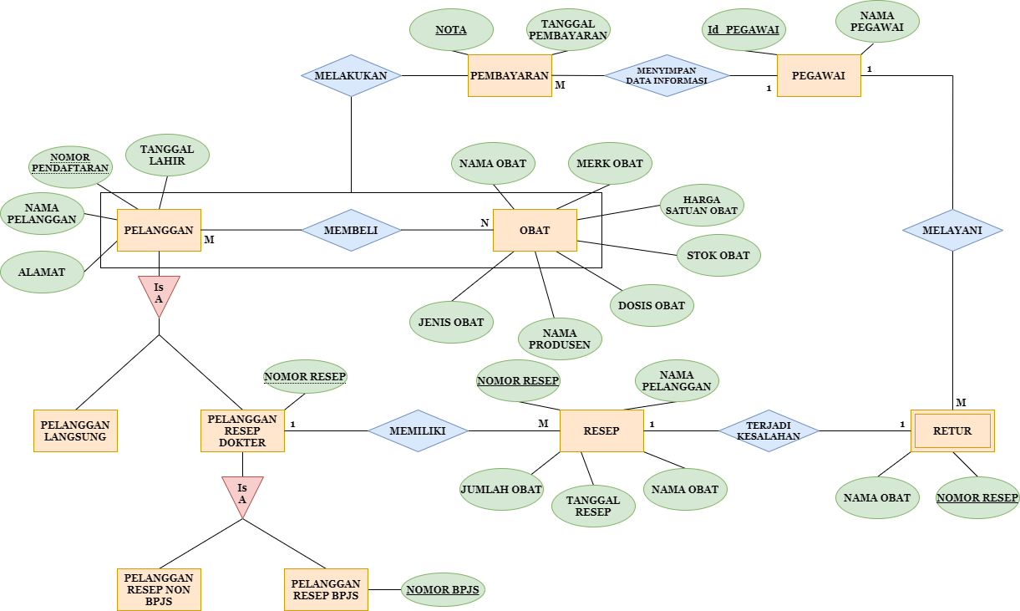

|  |  |  |
| --- | --- | --- |
| ATTRIBUTE | TIPE DATA | CONSTRAIN |
| No. Daftar | VARCHAR | Primary Key, NOT NULL |
| Nama Pelanggan | TEXT | NOT NULL |
| Alamat | TEXT | NOT NULL |
| Tanggal Lahir | DATE | NOT NULL |

1. PELANGGAN LANGSUNG



|  |  |  |
| --- | --- | --- |
| ATTRIBUTE | TIPE DATA | CONSTRAIN |
|  |  |  |
|  |  |  |

1. PELANGGAN RESEP DOKTER



|  |  |  |
| --- | --- | --- |
| ATTRIBUTE | TIPE DATA | CONSTRAIN |
| NOMOR RESEP | VARCHAR | FOREIGN KEY, NOT NULL |

1. PELANGGAN RESEP NON BPJS



|  |  |  |
| --- | --- | --- |
| ATTRIBUTE | TIPE DATA | CONSTRAIN |
|  |  |  |
|  |  |  |

1. PELANGGAN RESEP BPJ



|  |  |  |
| --- | --- | --- |
| ATTRIBUTE | TIPE DATA | CONSTRAIN |
| NOMOR BPJS | CHAR | PRIMARY KEY, NOT NULL |

1. OBAT



|  |  |  |
| --- | --- | --- |
| ATTRIBUTE | TIPE DATA | CONSTRAIN |
| NAMA OBAT | VARCHAR | NOT NULL |
| MERK OBAT | VARCHAR | NOT NULL |
| HARGA SATUAN OBAT | DECIMAL (size d) | NOT NULL |
| STOK OBAT | VARCHAR | NOT NULL |
| DOSIS OBAT | VARCHAR | NOT NULL, UNIQUE |
| NAMA PRODUSEN | TEXT | NOT NULL |
| JENIS OBAT | TEXT | NOT NULL |

1. PEMBAYARAN



|  |  |  |
| --- | --- | --- |
| ATTRIBUTE | TIPE DATA | CONSTRAIN |
| NOTA | VARCHAR, DECIMAL, FLOAT | PRIMARY KEY, NOT NULL |
| TANGGAL PEMBAYARAN | DATE | NOT NULL |

1. PEGAWAI



|  |  |  |
| --- | --- | --- |
| ATTRIBUTE | TIPE DATA | CONSTRAIN |
| ID PEGAWAI | VARCHAR | PRIMARY KEY,  NOT NULL |
| NAMA PEGAWAI | TEXT | NOT NULL |

1. RETUR



|  |  |  |
| --- | --- | --- |
| ATTRIBUTE | TIPE DATA | CONSTRAIN |
| NOMOR RESEP | VARCHAR | FOREIGN KEY,  NOT NULL |
| NAMA OBAT | TEXT | NOT NULL |

1. RESEP



|  |  |  |
| --- | --- | --- |
| ATTRIBUTE | TIPE DATA | CONSTRAIN |
| NOMOR RESEP | VARCHAR | PRIMARY KEY,  NOT NULL |
| TANGGAL RESEP | DATE | NOT NULL |
| JUMLAH OBAT | VARCHAR | NOT NULL |
| NAMA OBAT | TEXT | NOT NULL |
| NAMA PELANGGAN | TEXT | NOT NULL |